Day 05

LAB 01 – Linux Environment Discovery

Before changing a system, learn to Identify the environment you are working on

Show kernel & system information
- uname -a
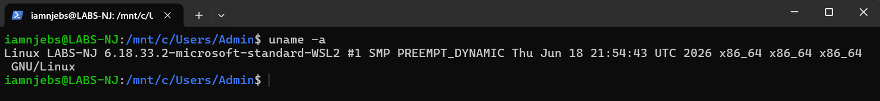

Show system OS information
- cat /etc/os/-release
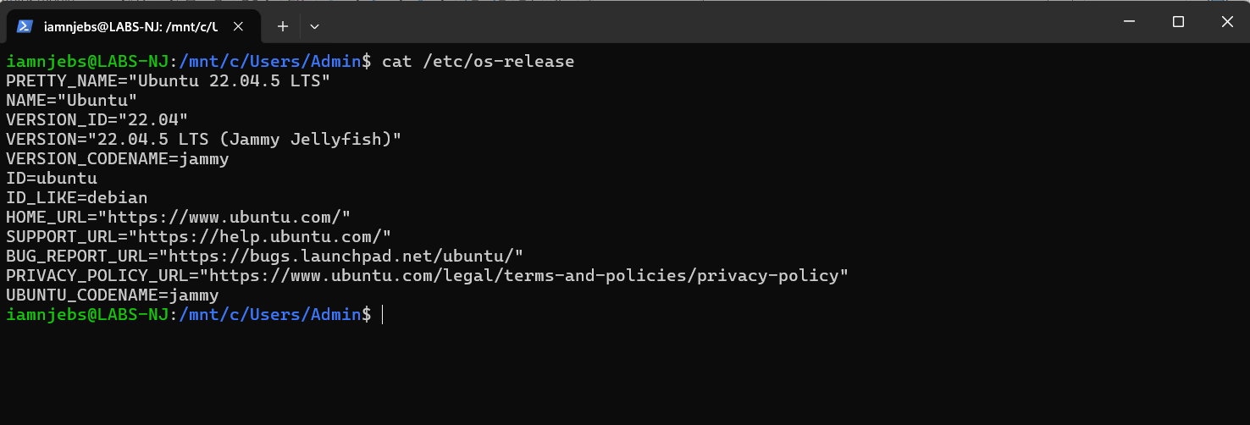

Show system hostname
- hostname
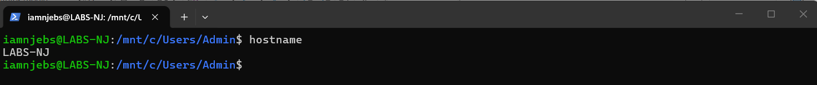

Show network interfaces & IP address
- ip addr
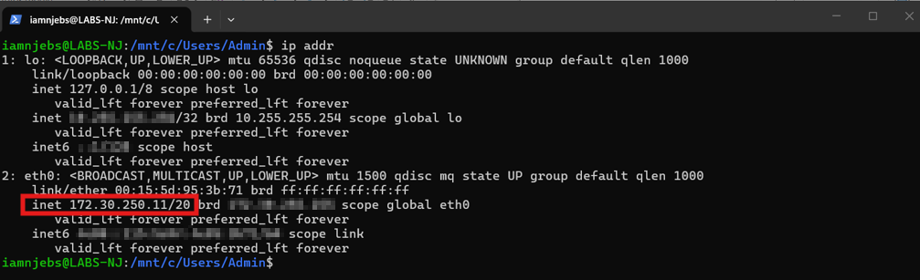
Show disk usage (human readable)
- dh -h
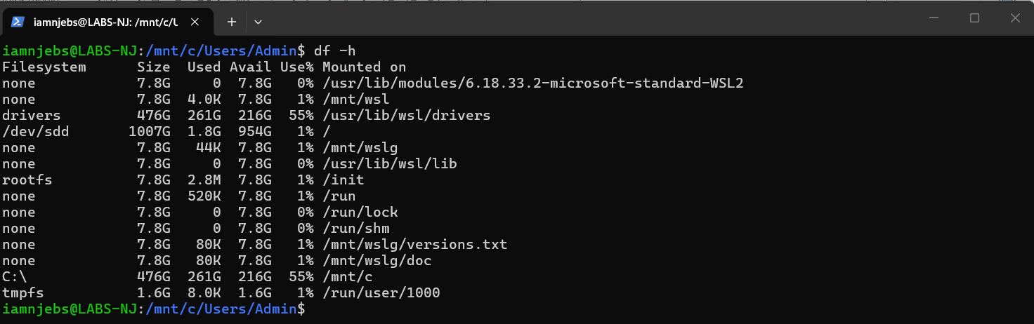

Show Available memory (human readable)
- free -h
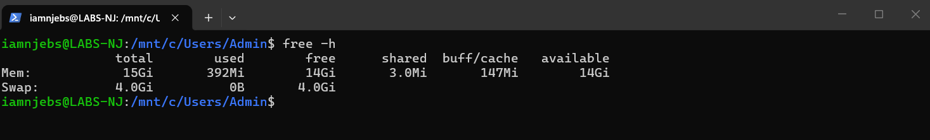
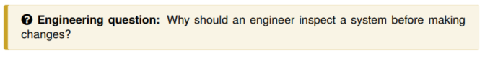
Answers:
- to make sure you know their system capacity, for example system name, OS, CPU, Memory and what limitations the system has.
- This helps engineers to identify what, where they need to make/ modify system changes example directory folder, files, script etc. etc.
- And this prevents downtime, avoids unnecessary costs and protects data security.

LAB 02 SSH Access
Tried to ssh to localhost
- ssh iamnjebs@localhost
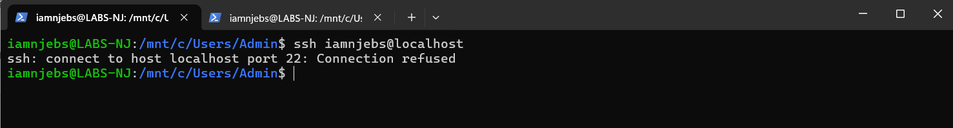
- ssh localhost
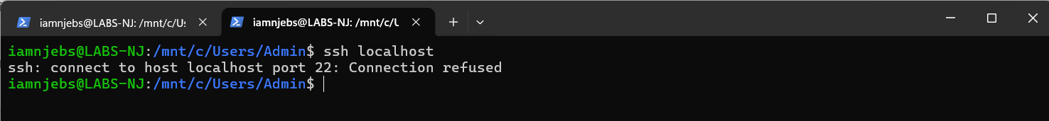
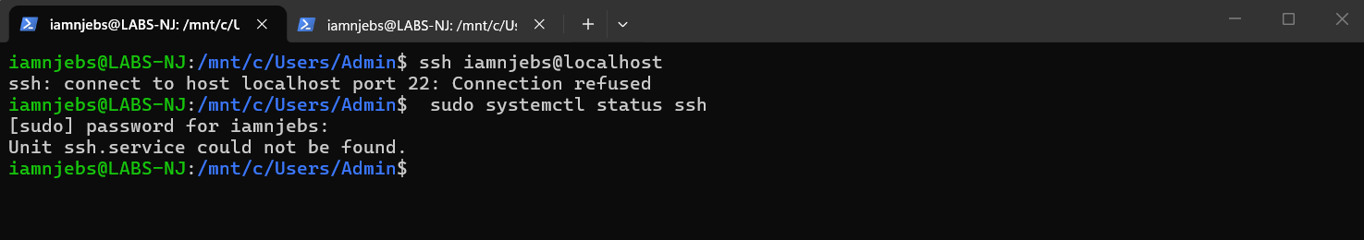

Install OpenSSH Server
- sudo apt update
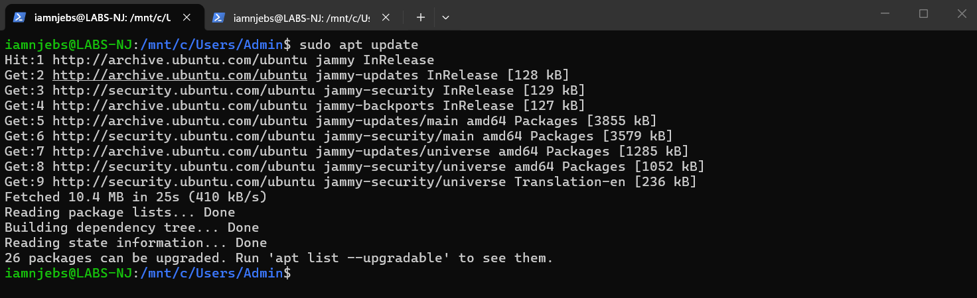

- sudo apt install openssh-server -y
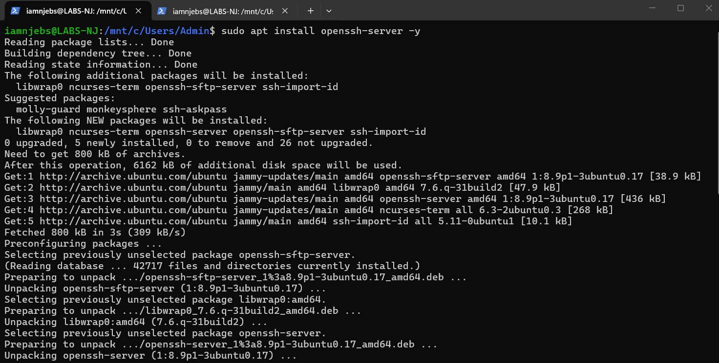
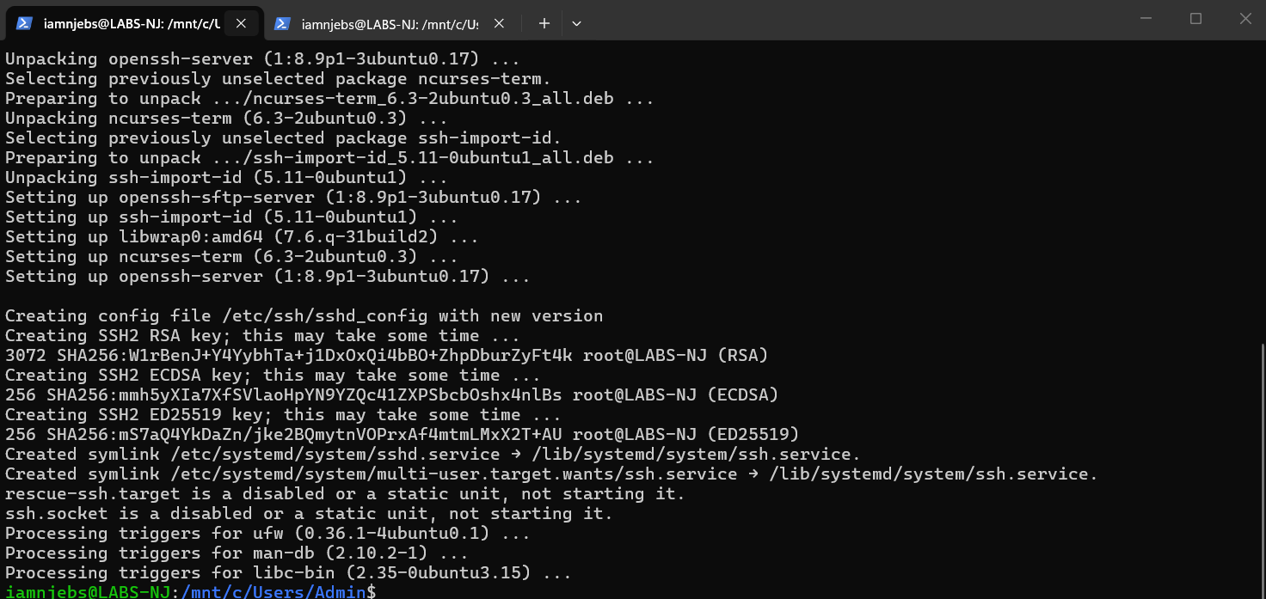

Start & Enable the SSH Service
- sudo apt enable –-now ssh
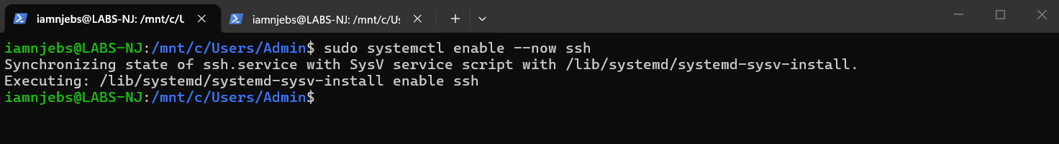
Verify SSH Service Status
- sudo systemctl status ssh
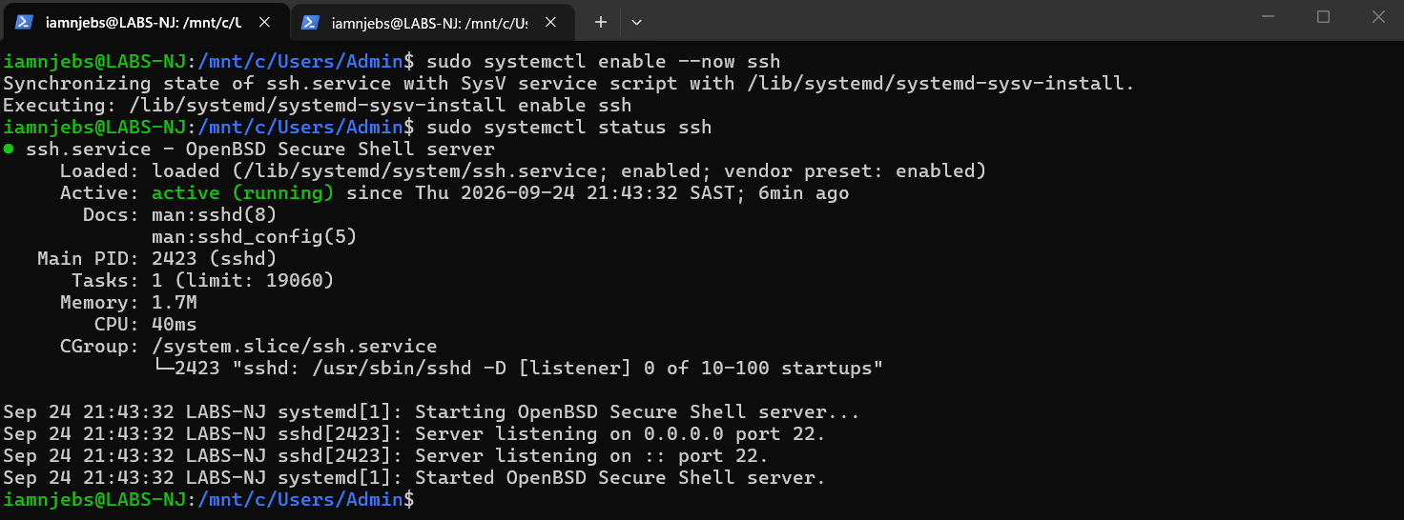

Connect to Localhost
- ssh iamnjebs@localhost
- ssh iamnjebs@172.30.250.11
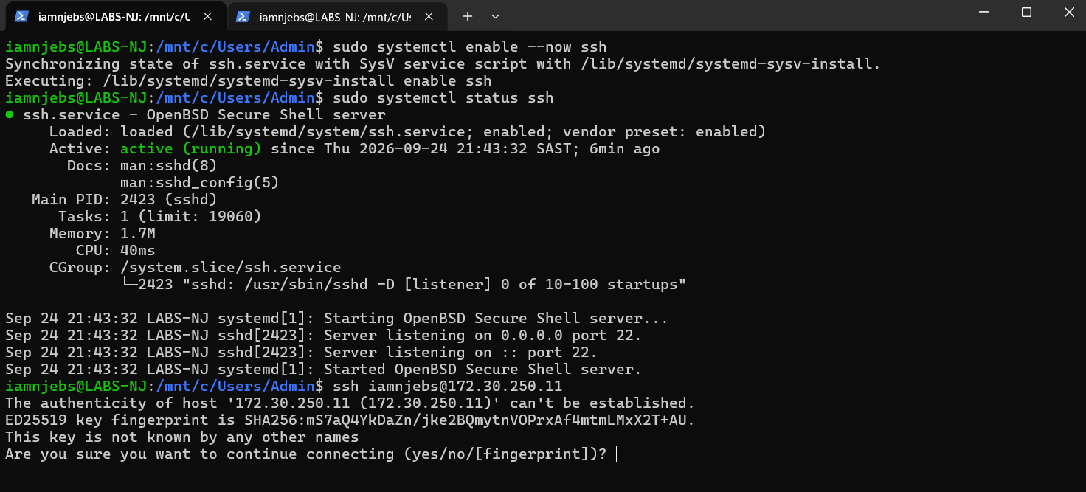
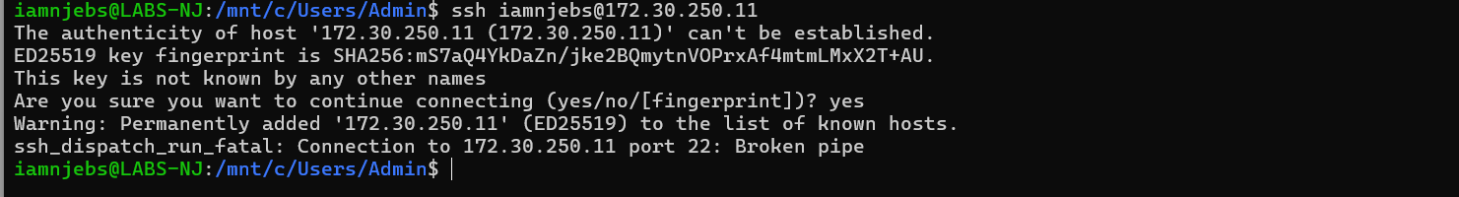
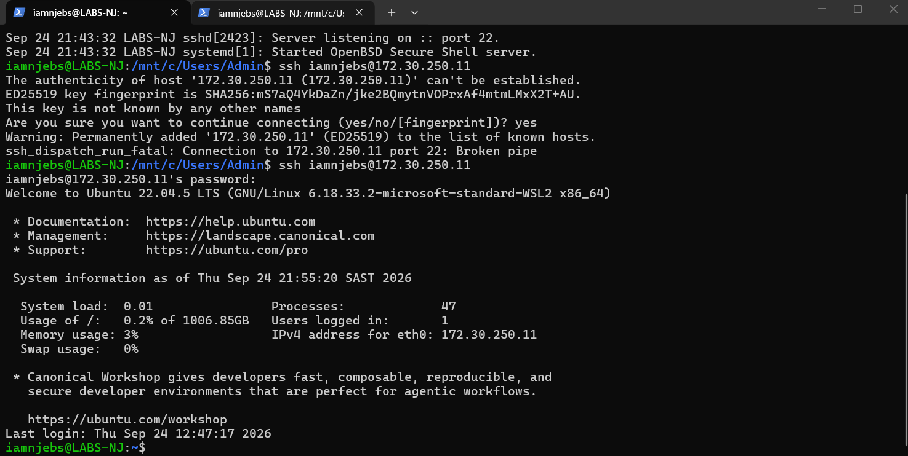

Connecting using Putty
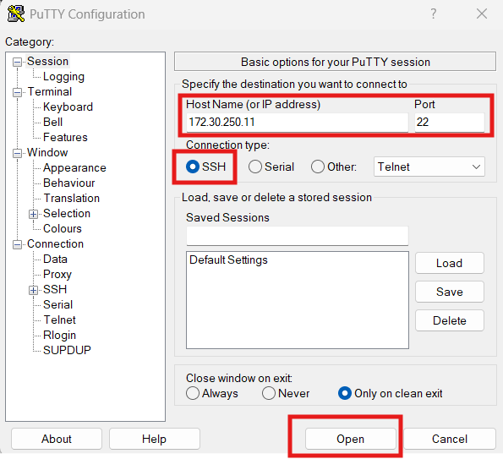
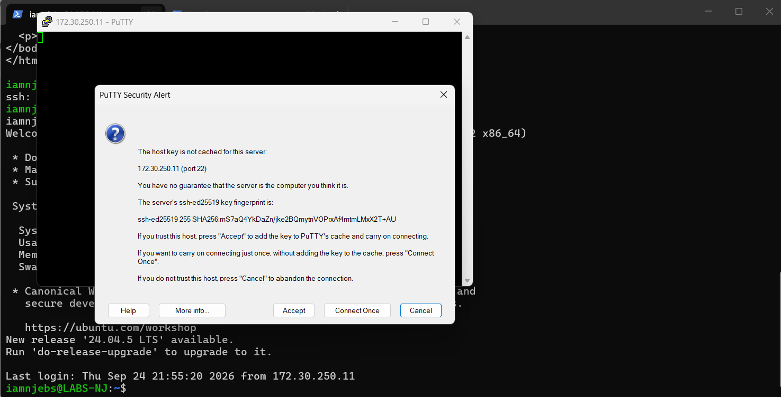

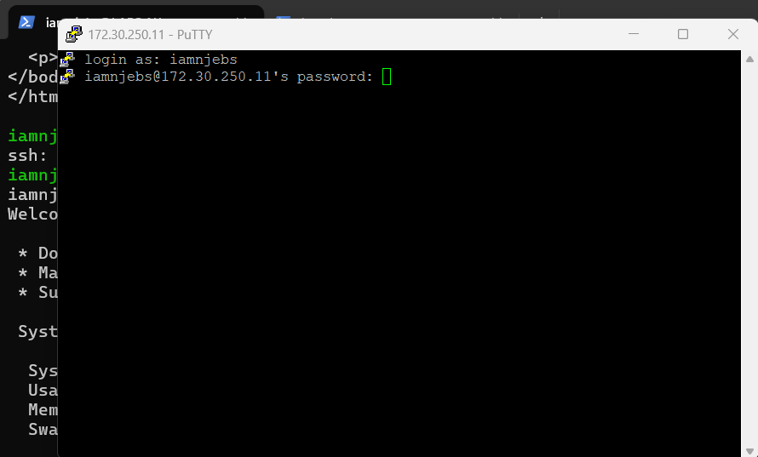

Inside Putty: output
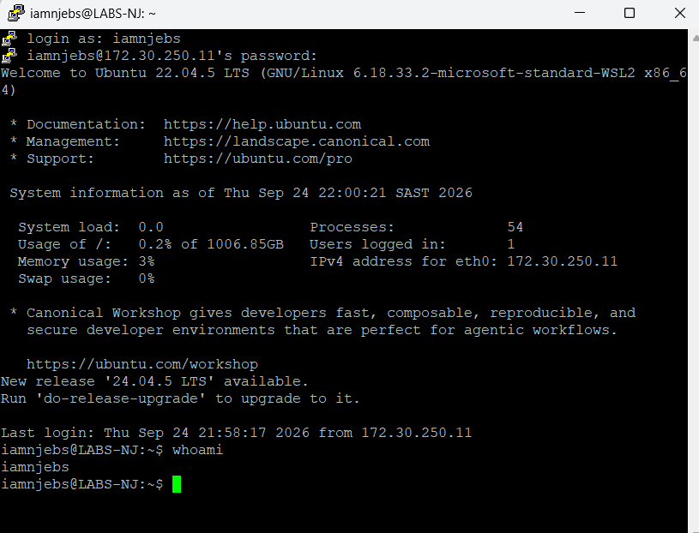

SSH Service Disable
- sudo systemctl disable --now ssh
Verify SSH Service Status
- sudo systemctl status ssh
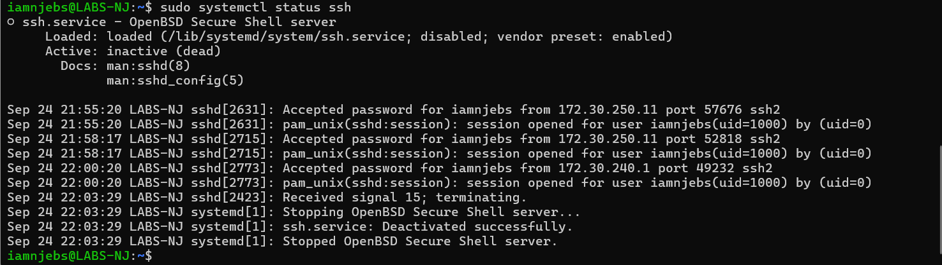
Putty to confirm ssh is disabled
- connection refused
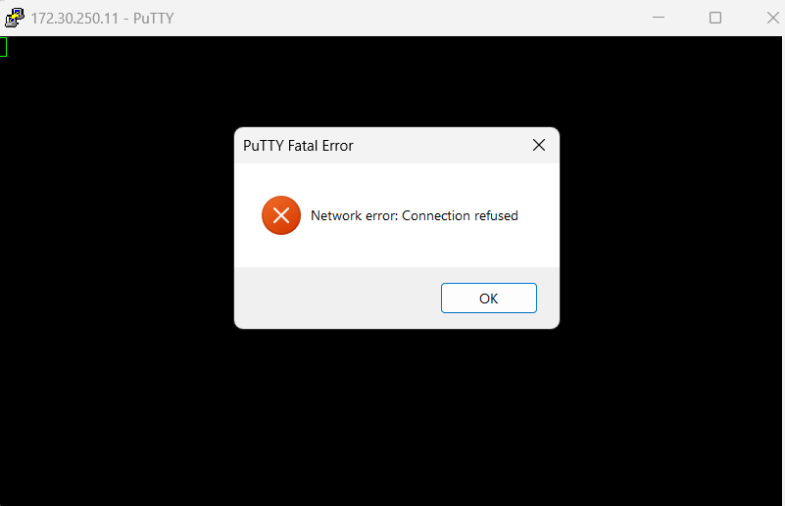

LAB 03 – Install Nginx

Update the package Information:
- sudo apt update
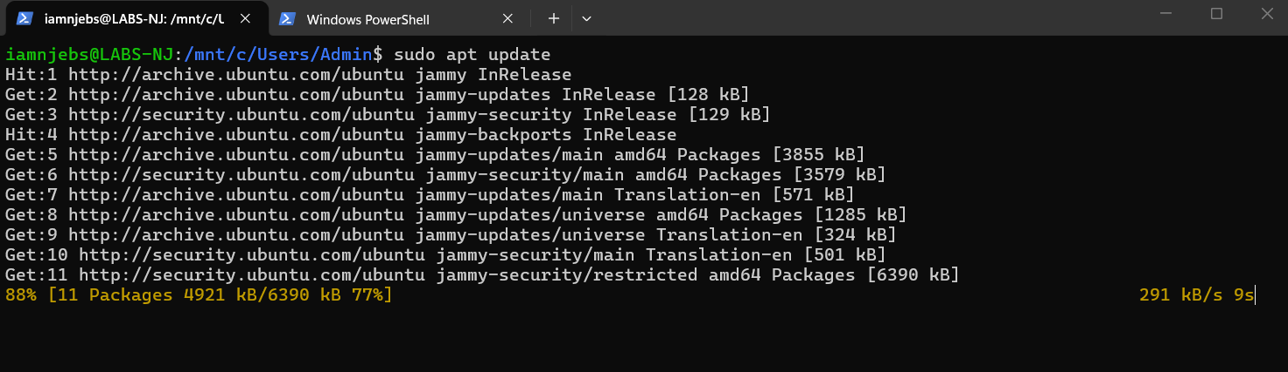
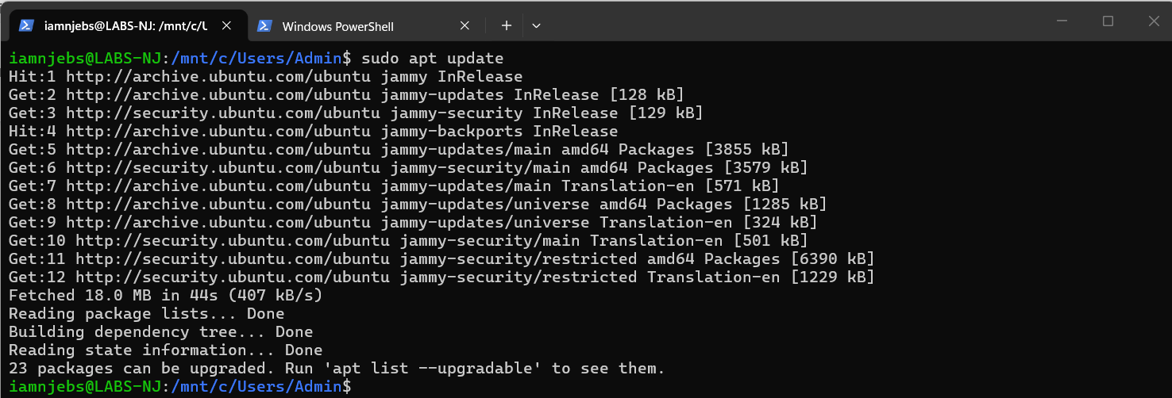

Install Nginx
- sudo apt install nginx -y
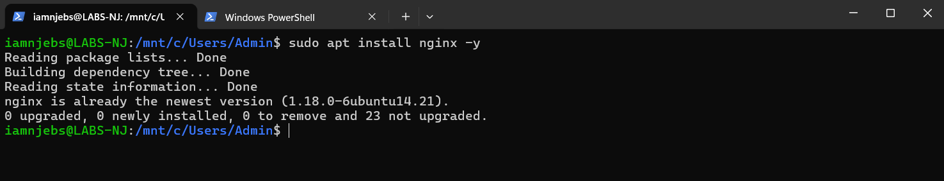

Check the service:
- sudo systemctl status nginx
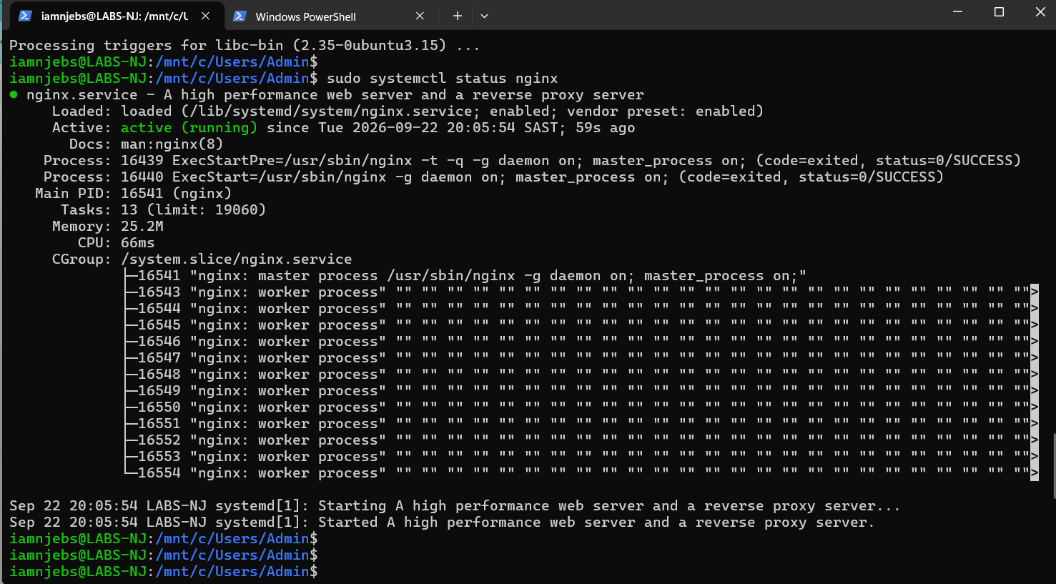

If necessary, start & enable nginx:
- sudo systemctl status nginx
- sudo systemctl enable nginx
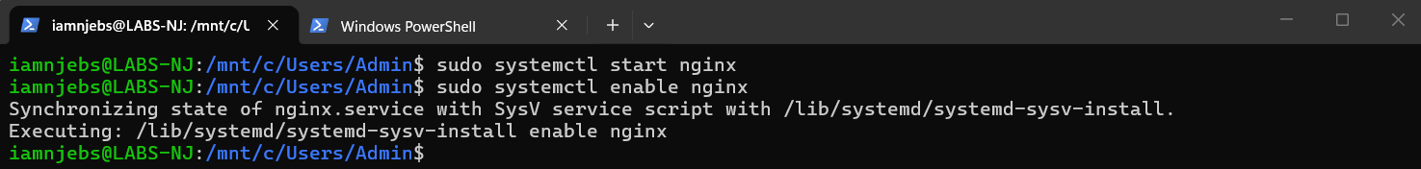
Verify
- curl localhost
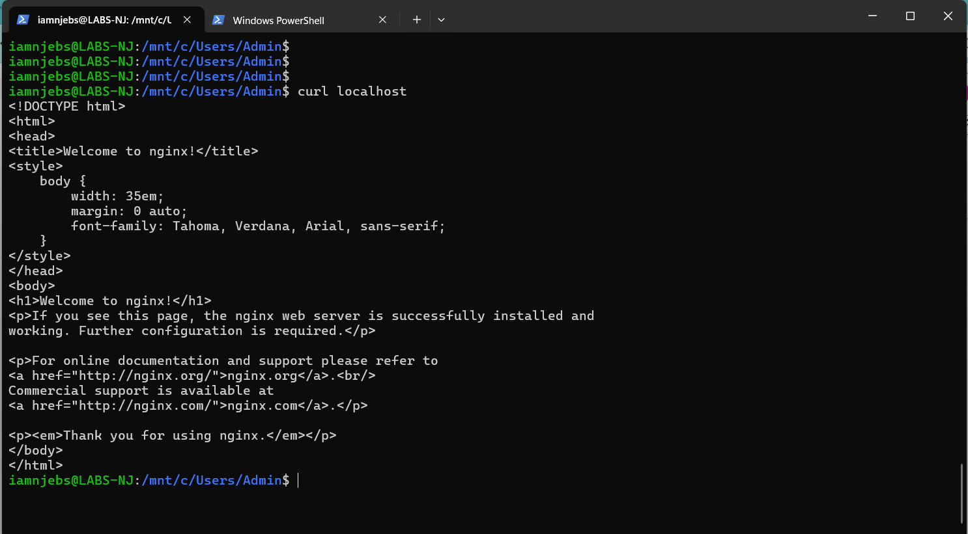

LAB 04 Understanding the Nginx Service
Check Service Status
- sudo systemctl status nginx
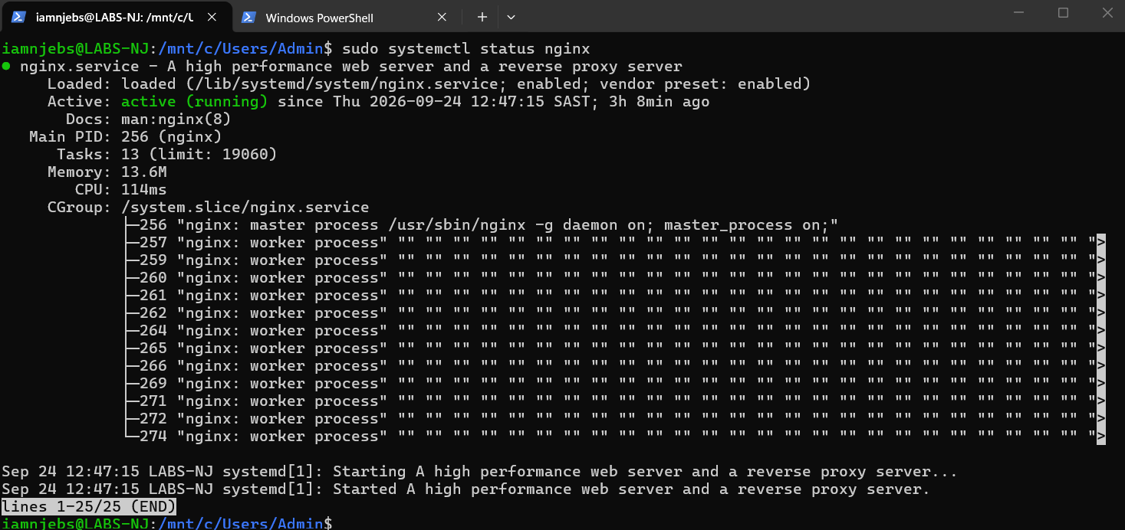
Stop Service
- sudo systemctl stop

Check Service Status
- sudo systemctl status nginx
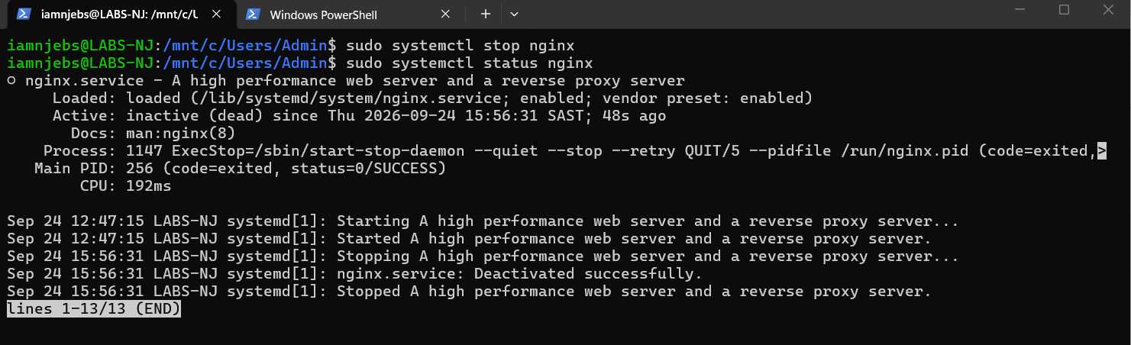

Start Service
- sudo systemctl start nginx
Check Service Status
- sudo systemctl status nginx
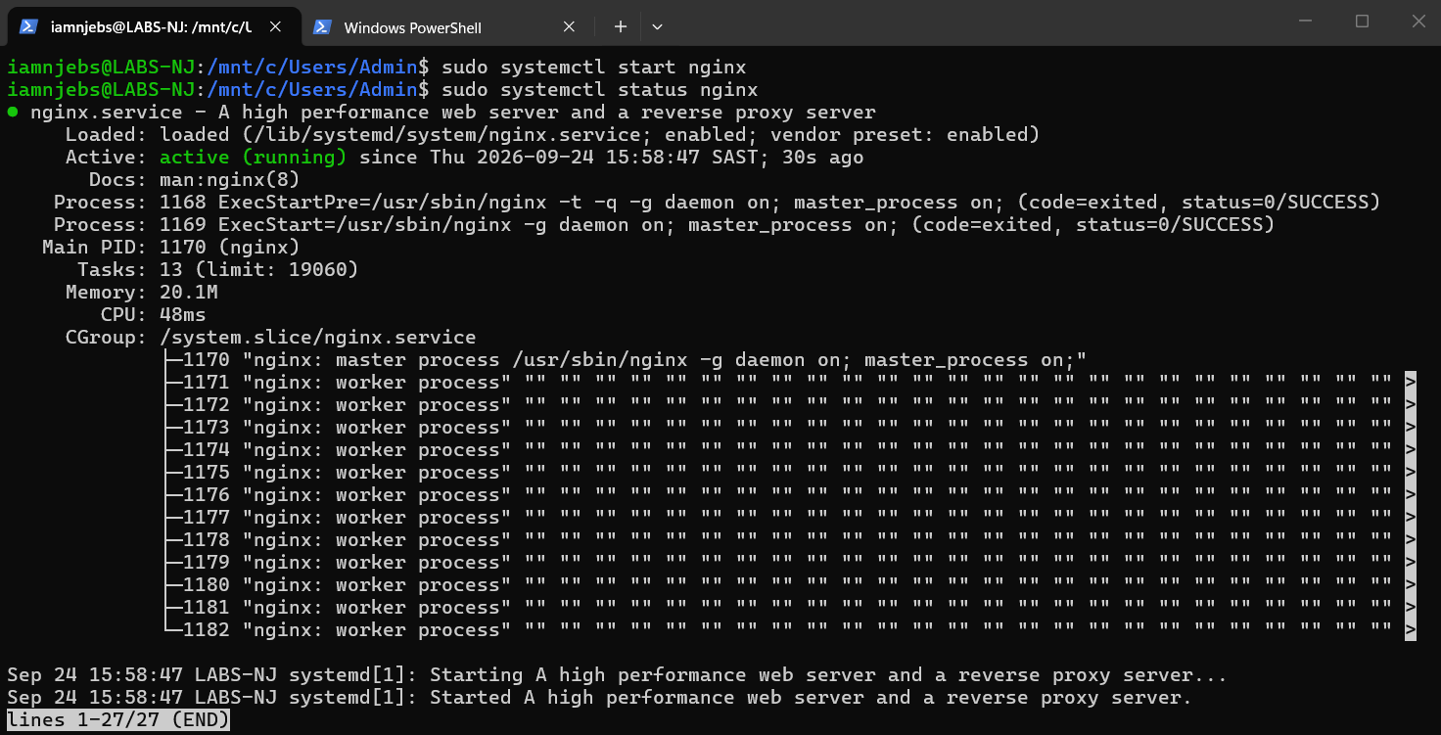

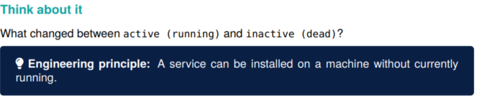
Answer: System status

LAB 05 Build Your Own Web Page

Web Page HTML Code:
<!DOCTYPE html>
<html>
<head>
<title>MZ-UCA Cloud Engineering</title>
</head>
<body>
<h1>MZ-UCA Cloud Engineering Lab</h1>
<p>Linux + Nginx Web Server</p>
<p>Engineer: Njabulo Khumalo</p>
<p>Environment: Ubuntu Linux</p>
</body>
</html>

Open Nano File & Paste the html code.
- sudo nano /var/www/html/index.html
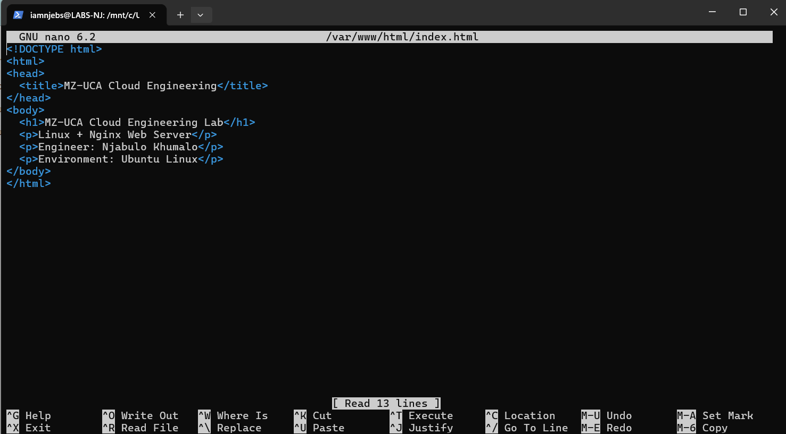
Save & exit
- ctrl + o + enter & ctrl + o + enter

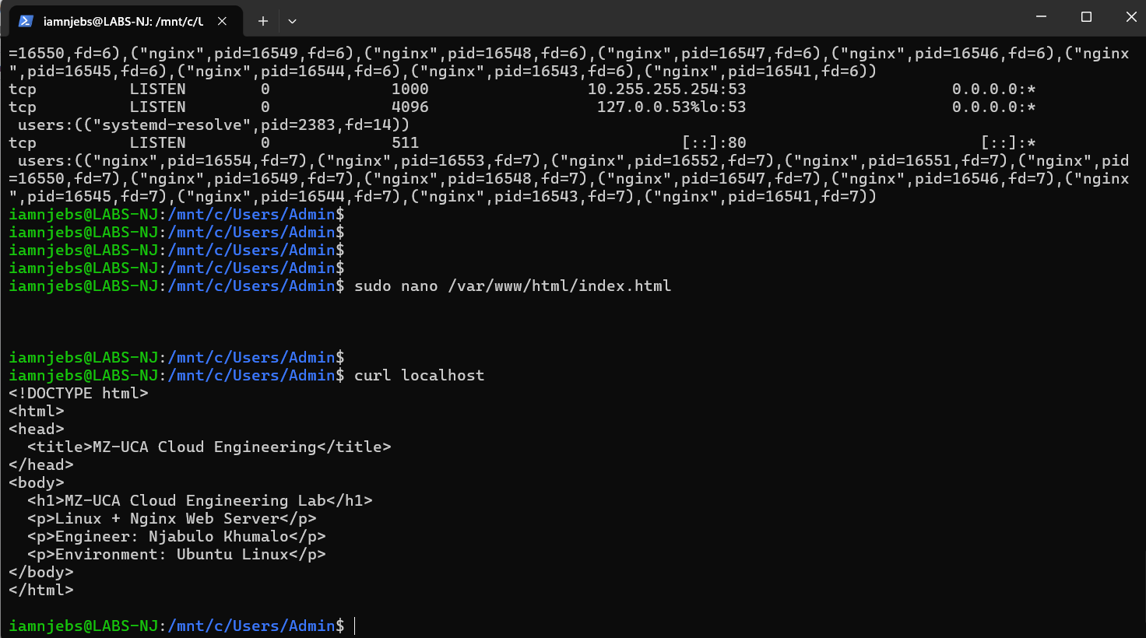

Open a browser and search for your webpage.
- http://172.30.250.11/
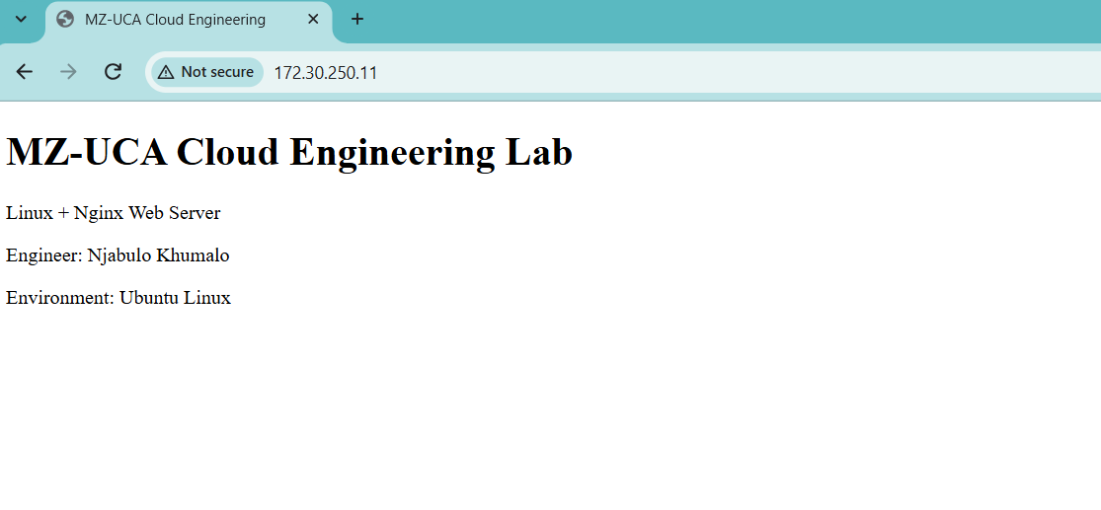

LAB 06 Understand Ports
Check Listening Services
- sudo ss -tulpn
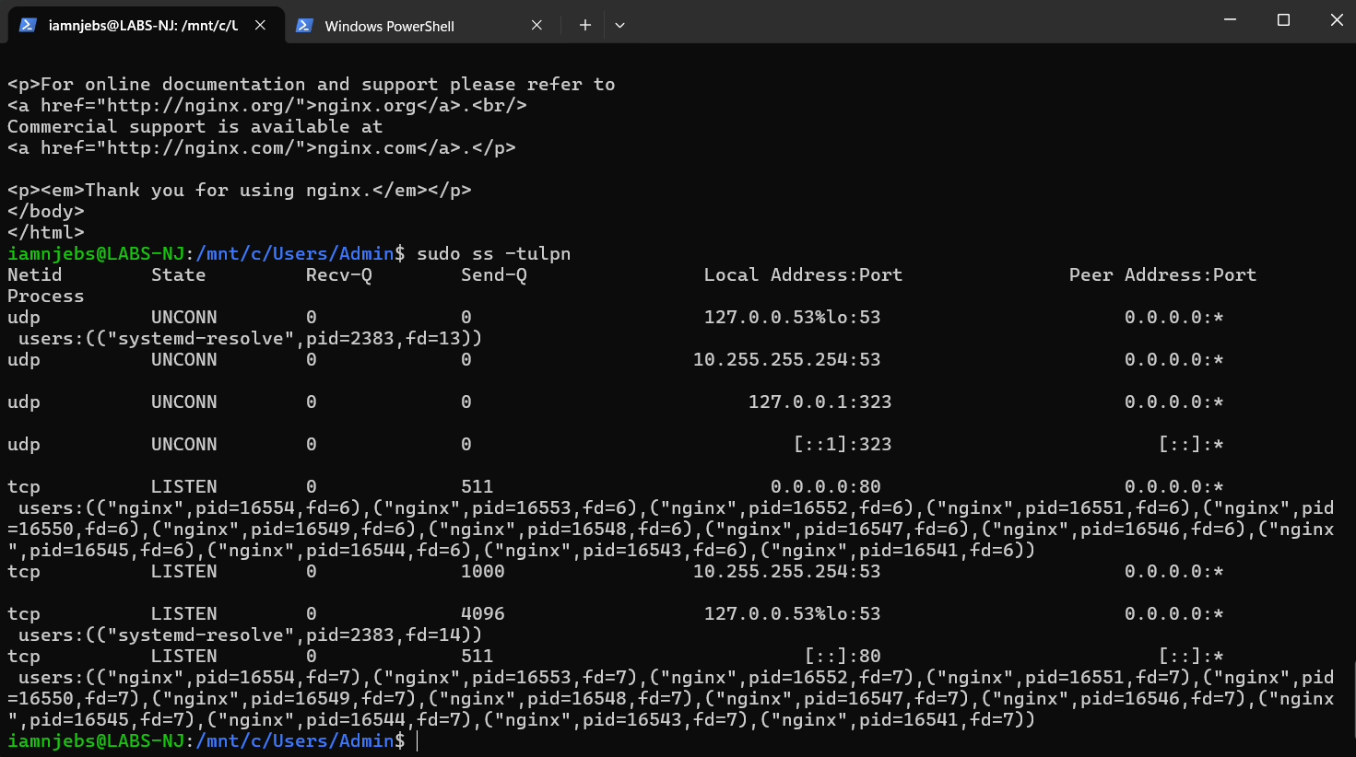
Listening Ports:
- Protocol (TCP/UDP) Port :53 DNS used for name resolution
- Protocol (TCP) Port :80 HTTP used default communication port for unencrypted traffic on the web.
NB: UNCONN (Unconnected) ports read to receive incoming packets
- These ports are open & listening for traffic (:53 DNS & :323 IMMP (Internet Message Mapping Protocol)

Show a specific port: 80
- sudo ss -tulpn | grep :80
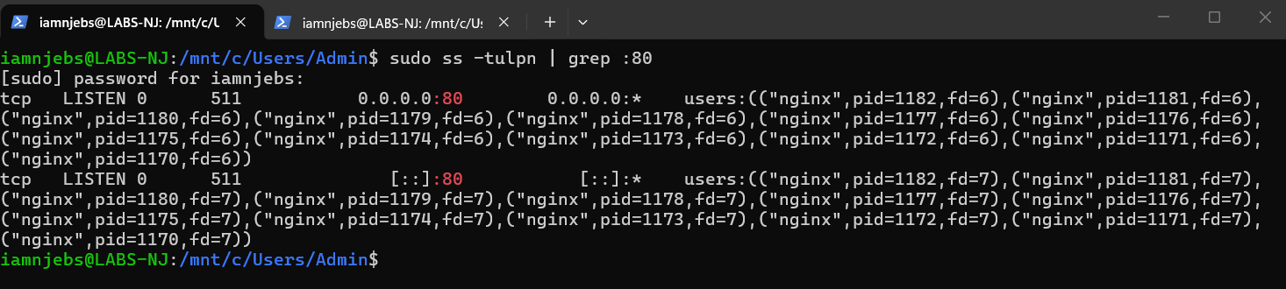

LAB 07 Configure the Firewall

Check for ufw & enable ufw
- sudo ufw status
- sudo ufw enable
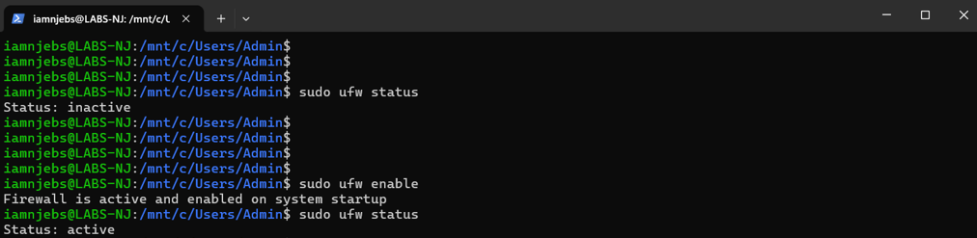
Allow SSH
- sudo ufw allow ssh
Allow HTTP
- sudo ufw allow 80/tcp

Check ufw status
- sudo ufw status
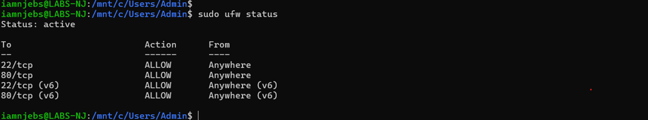

LAB 08 Test Connectivity
Verify web server responds local
- curl localhost
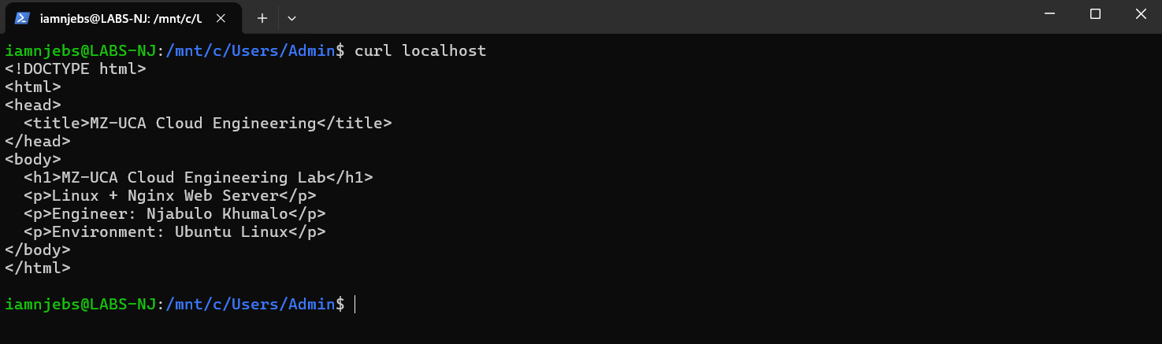

Identify network (IP & Interfaces)
- ip addr
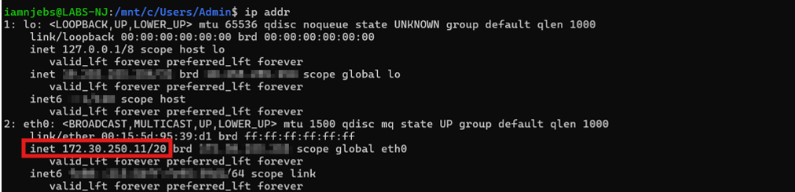
Verify your server using local server actual IP
- curl http://172.30.250.11

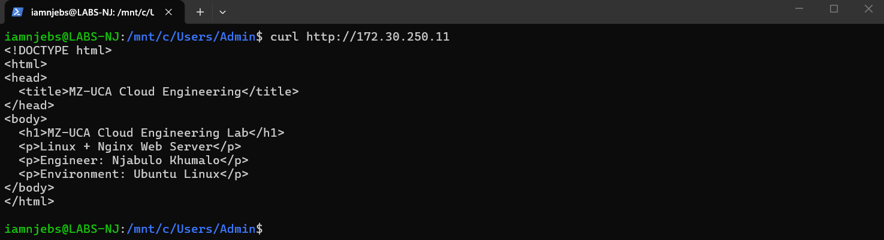

Test on the Browser (Chrome)
- https://172.30.250.11/
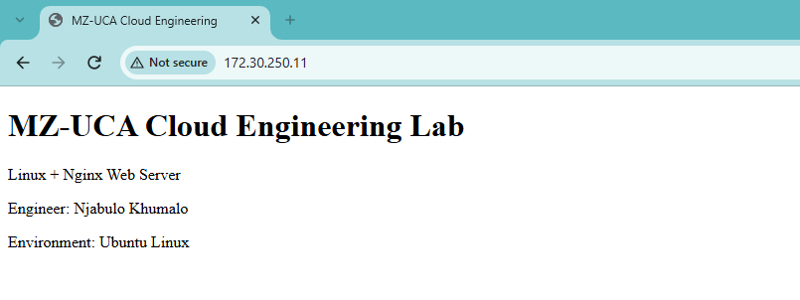

LAB 09 Access Logs

Check Logs
- sudo tail -f /var/log/nginx/access.log
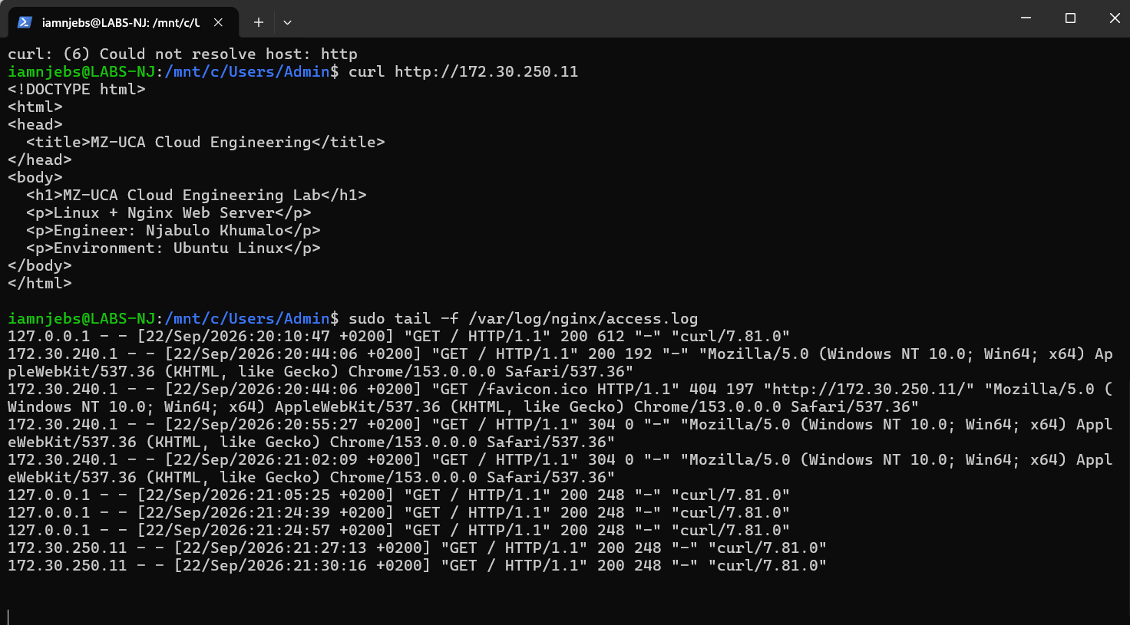
To escape
- control + C + Enter
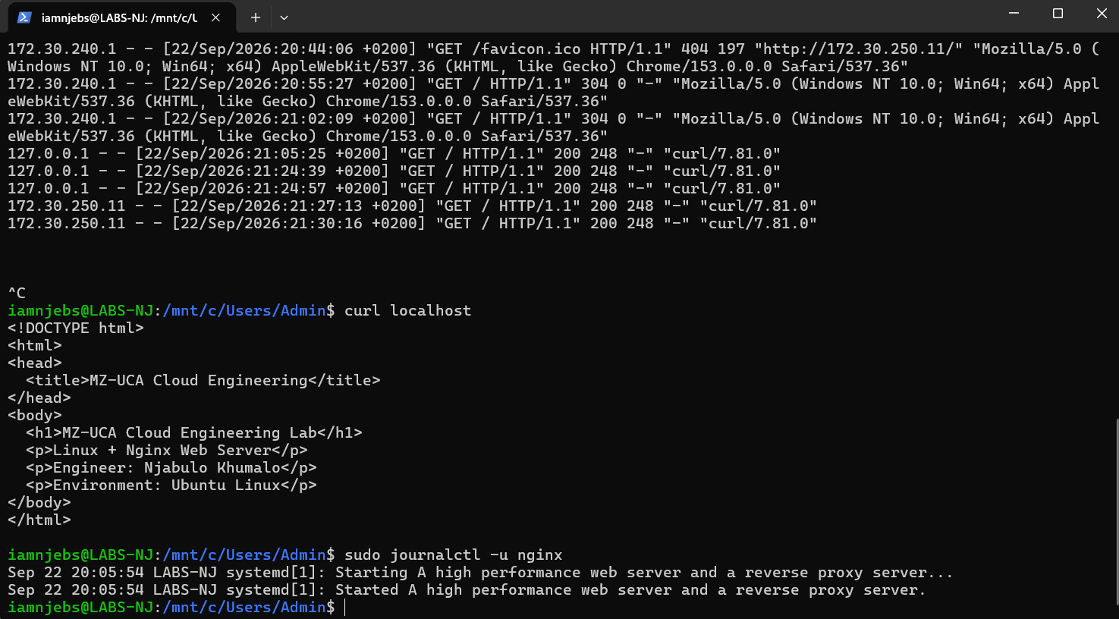

LAB 09 Access Log
Run and leave terminal running:
- sudo tail -f /var/log/nginx/access.log
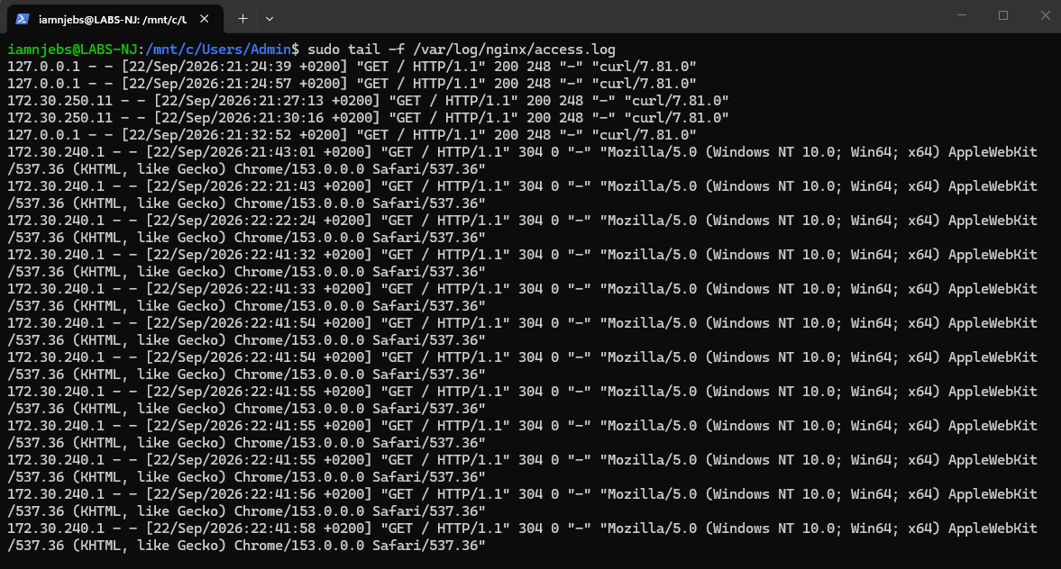
Observation:
- When I run (sudo tail -f /var/log/nginx/access.log) it shows logs and when I refresh the webpage (localhost) more logs are generated.

New Logs generated when running
- curl localhost
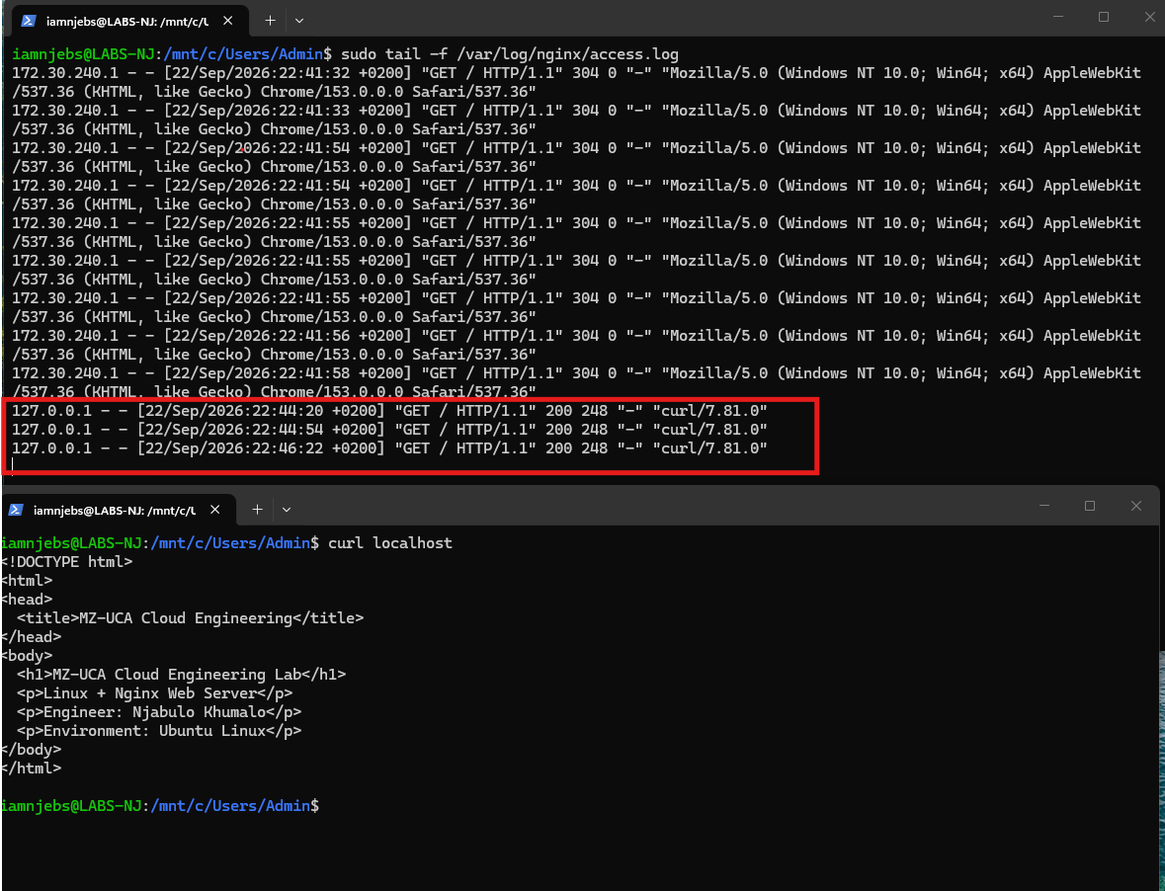
Observation:
- When I curl localhost new Logs are generated

LAB 10 Error Logs
Application errors investigation
- sudo tail -f /var/log/nginx/error.log
- sudo journalctl -u nginx
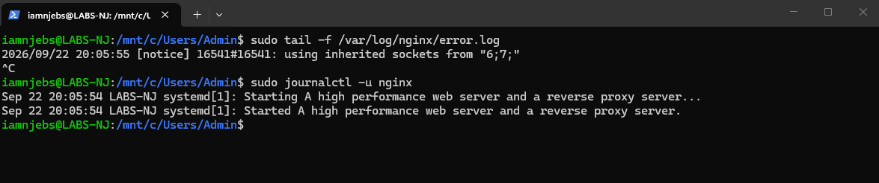
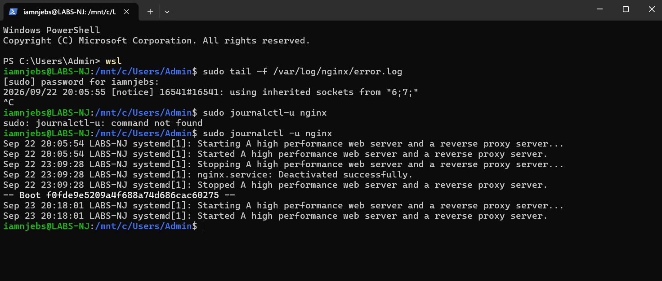
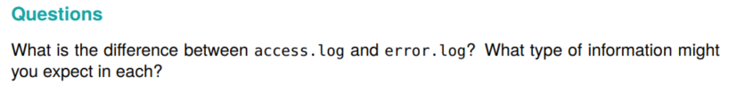
Answer:
- access.log are activity records (web page visits) and error.log are problem reports (web page/server issues)

LAB 11 - Break The Web Server

Stop Nginx Services
- sudo systemctl stop nginx
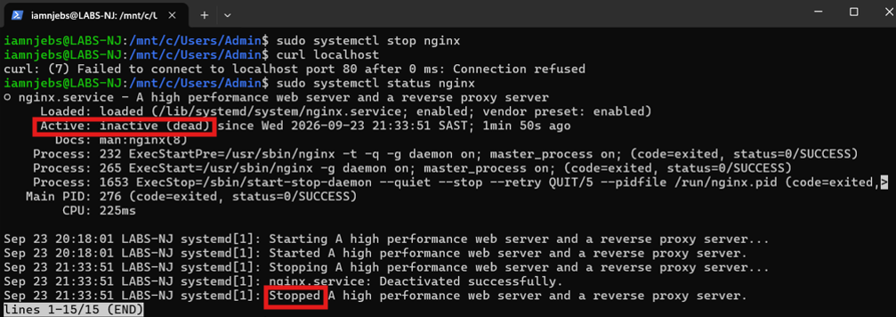
Test
- curl localhost

Investigate
- sudo systemctl status nginx
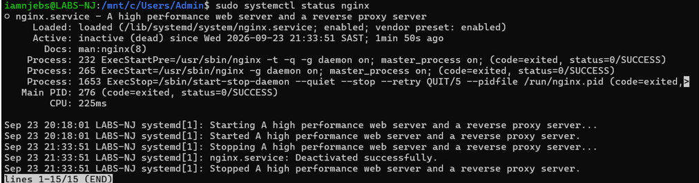
Run logs
- sudo journalctl -u nginx
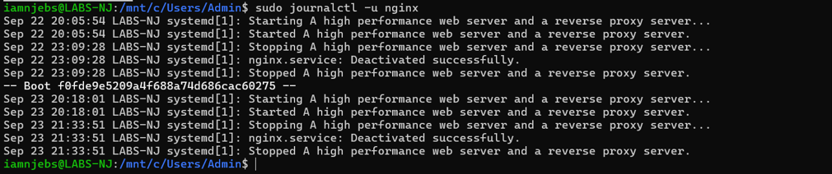
The webpage is unavailable because of the nginx service we deactivated
Recover the Nginx Service
- sudo systemctl start nginx
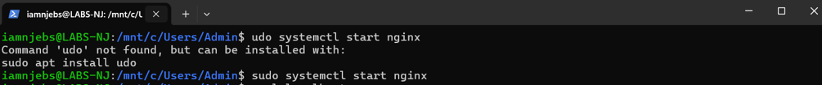
Typo error udo instead of sudo

Test again
- curl localhost
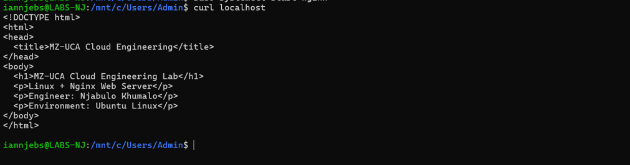

LAB 12 - Troubleshooting Challenge

1. Check Service
- sudo systemctl status nginx
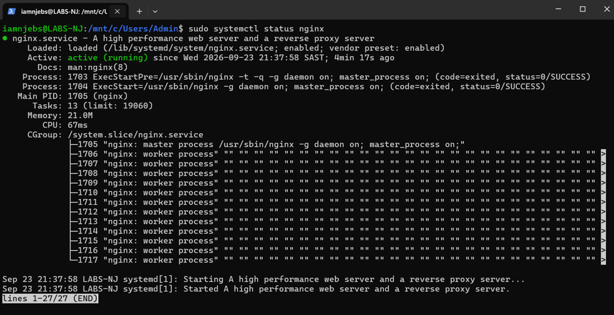

2. Port
- sudo ss -tulpn
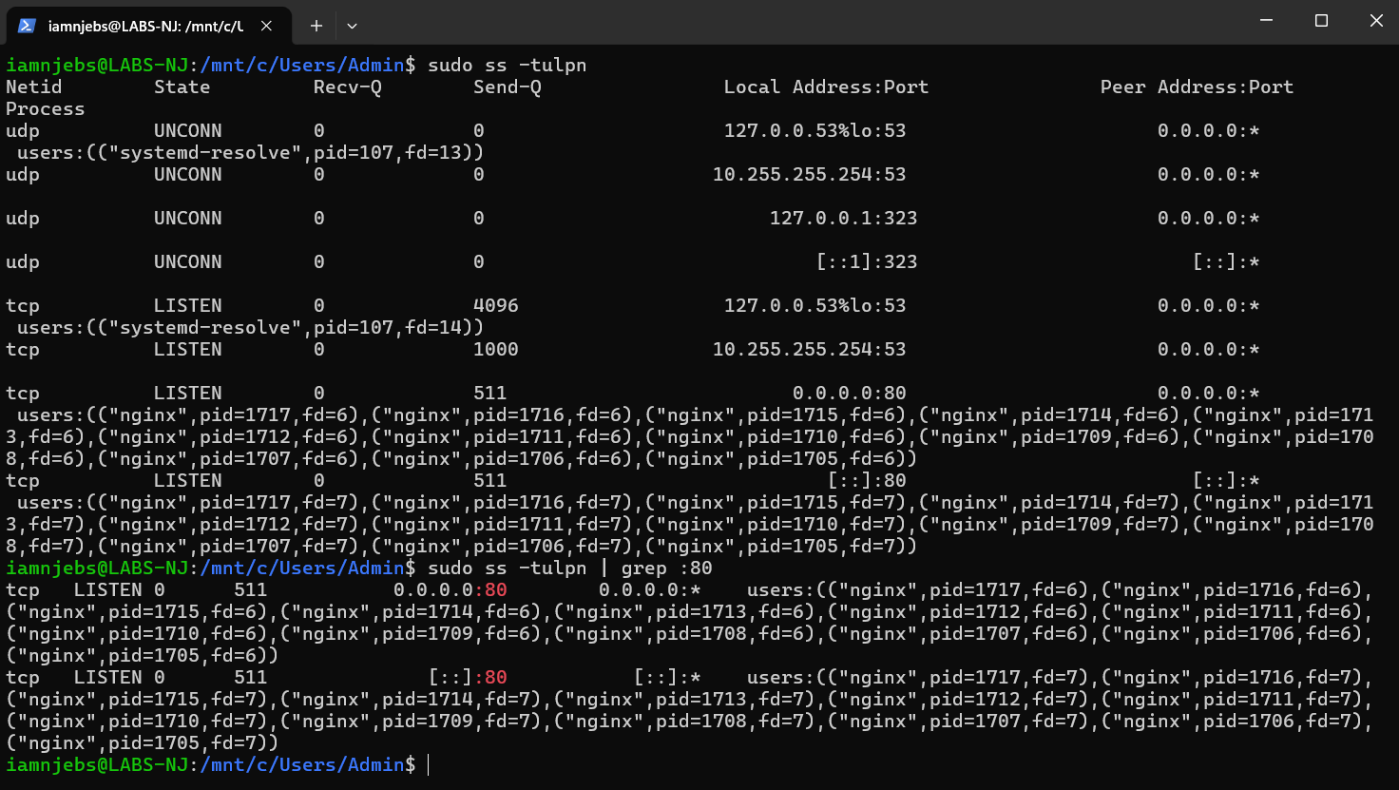

Check specific port :80
- sudo ss -tulpin | grep :80
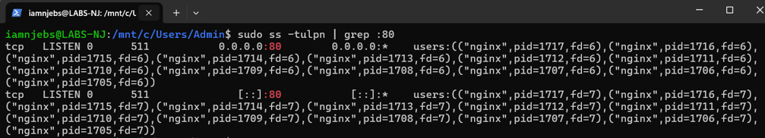

3. Network
- ip addr
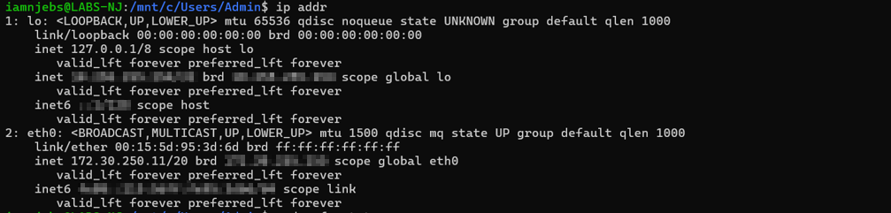
4. Firewall
- sudo ufw status
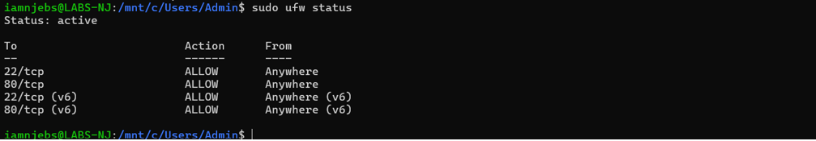

5. Logs
- sudo journalctl -u nginx
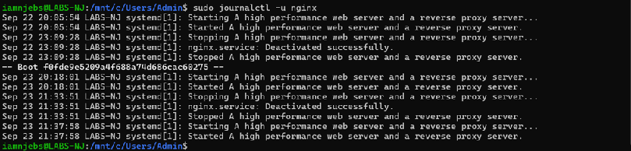
6. Configuration
- curl localhost
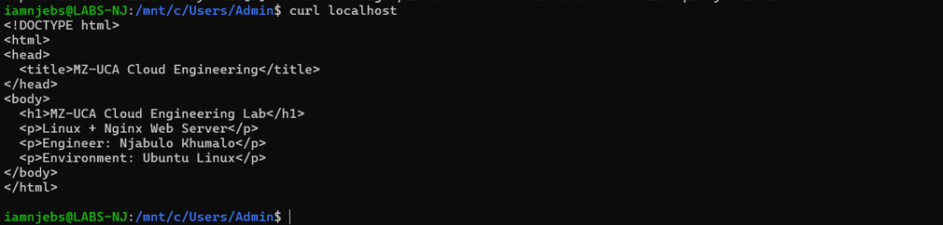

Problem: The website was down
Evidence: systemctl displayed inactive and curl localhost displayed fail
Root cause: Nginx stopped, port 80 was blocked by the ufw, there were some misconfigurations
Resolution: I restart Nginx, fixed the ufw and correct configurations
Verification: the webpage successfully returned by testing curl localhost

LAB 13 - Engineering Evidence

Screenshots Folder
- name: day-05-screenshots
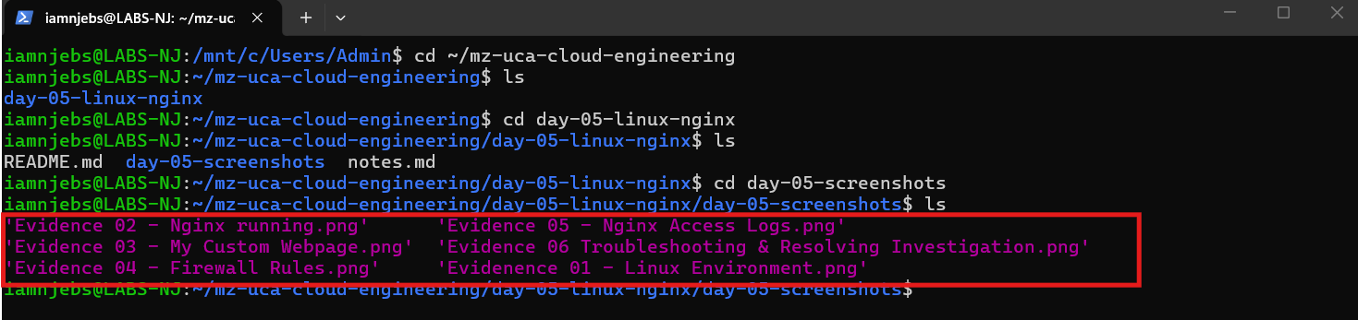

LAB 14 Create Your Lab Notes
Created Folder Outside Cloud-Engineering Folder
- mkdir -p ~/mz-uca-cloud-engineering/day-05-linux-nginx
Inside the Folder
- cd ~/mz-uca-cloud-engineering/day-05-linux-nginx
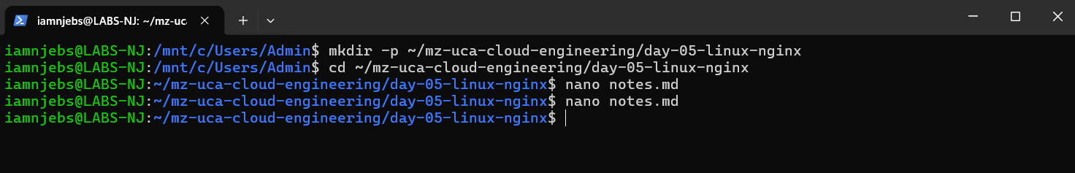
Create a notes file:
- nano notes.md
Paste as shown below save and exit
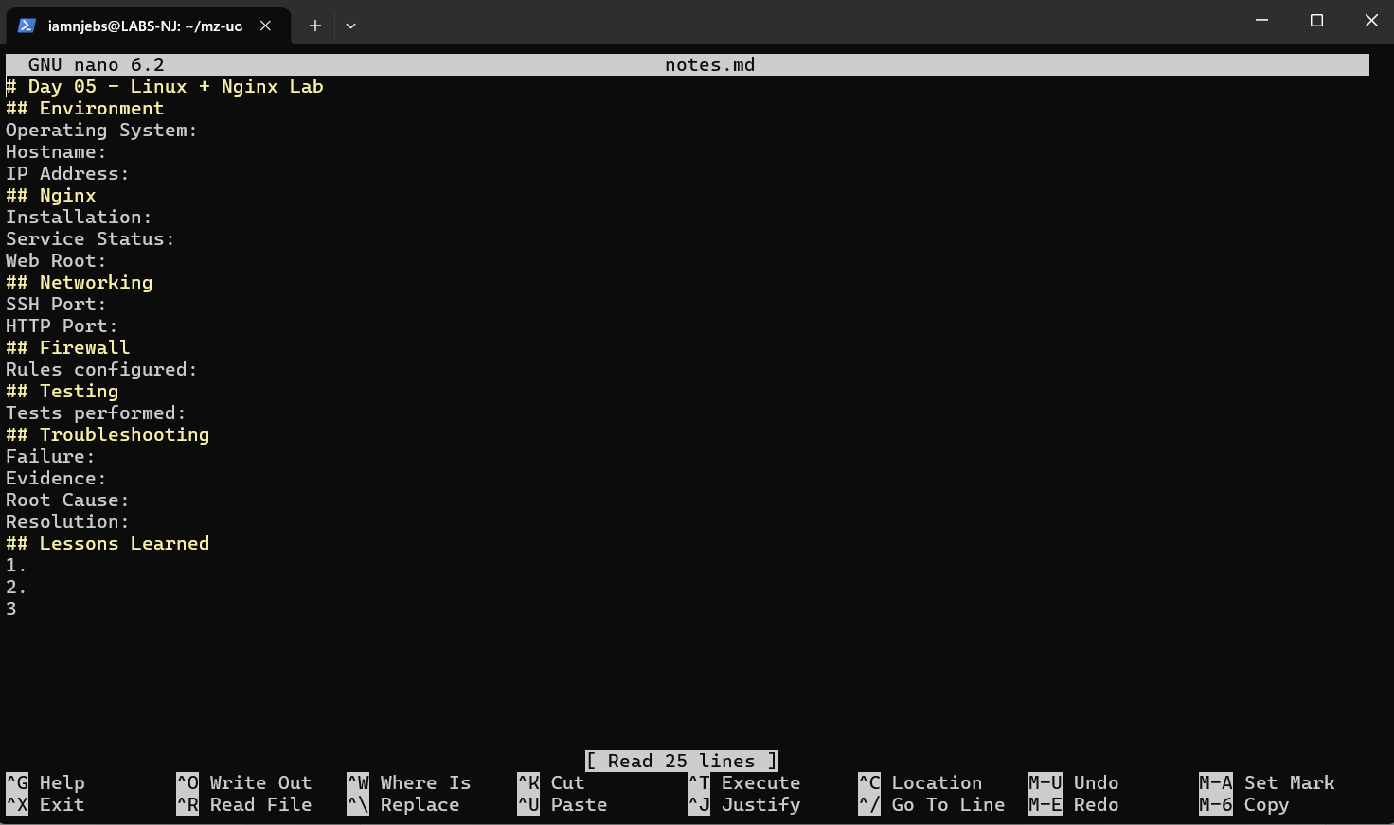

Git Upload
Created another folder for documantion
- mkdir documentation

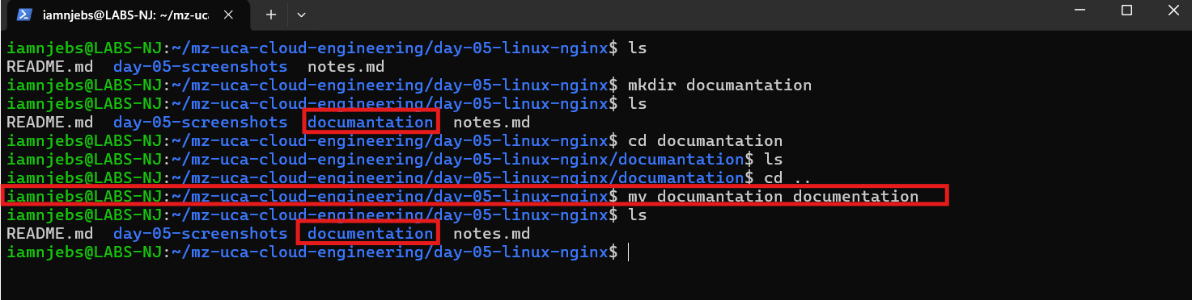
I update/rename the typo error for documentation
- mv documantation documentation

